**GIT LAB ASSIGNMENT**

**NAME :** SYED ALI FATHIMA M

**ROLL NO :** 731621121055

**EMAIL** : [fathimamusthakali@gmail.com](mailto:fathimamusthakali@gmail.com)

**GIT ASSIGNMENT 01**

1. **Create a local git repo with the name "MyRepo".**

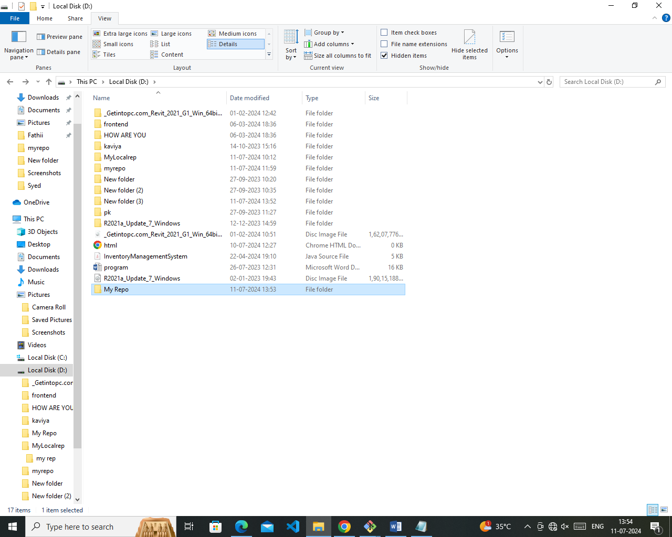

1. **Create one .txt file, five .c files and five .java files in the working area.**

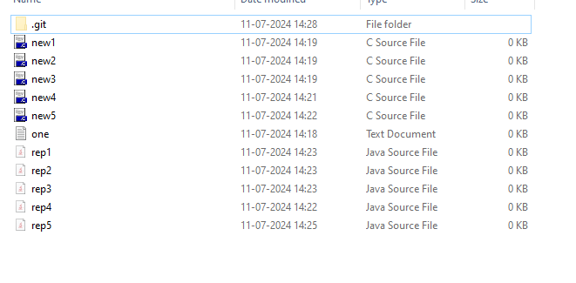

1. **Verify the git status**

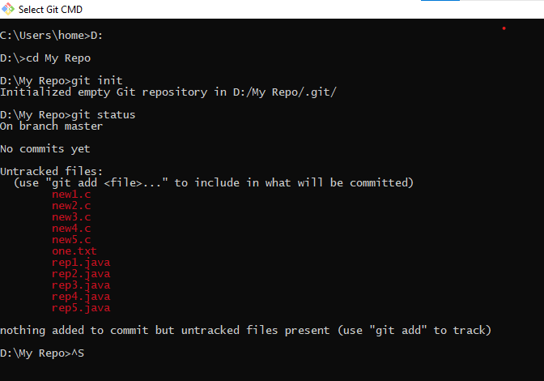

1. **Add only the .txt into the staging area**
2. **verify the git status**
3. 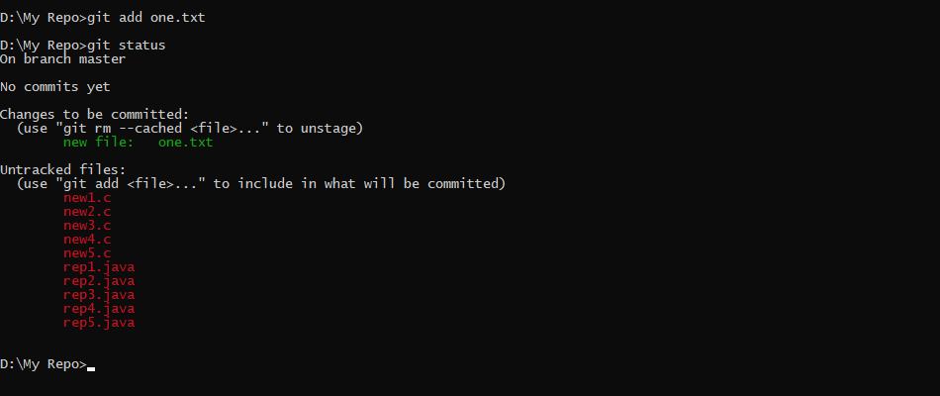

**6.Make a commit with the name "TXT Commit"**

**7. Add all .c files into the staging area.**

**8. verify the git status.**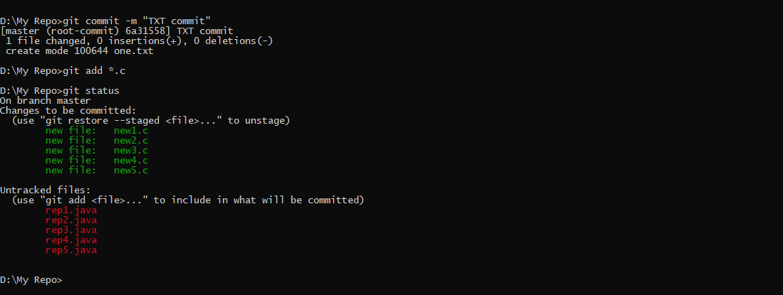

**9. Make a commit with the name "C Commit”.**

**10 .Add all .javafiles into the staging area. 11. verify the git status.** 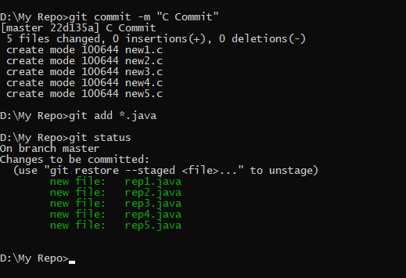

**12. Make a commit with the name "Java Commit"**

**13. Delete all .java files from working area**

**14. Now see the status.**

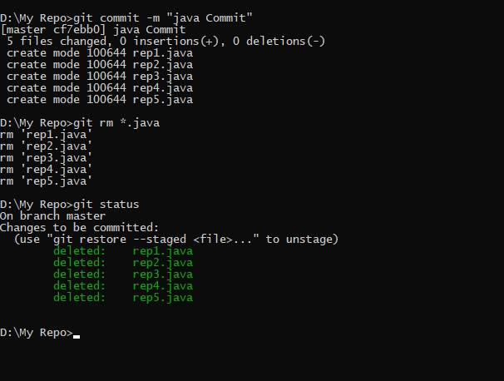

**15. add the changes into the staging area**

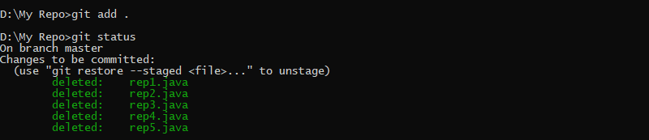

**16. Make a commit with the name "Delete Java Commit"**

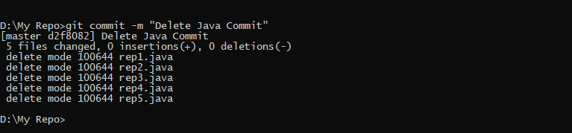

**17.** **display all commit details.**

